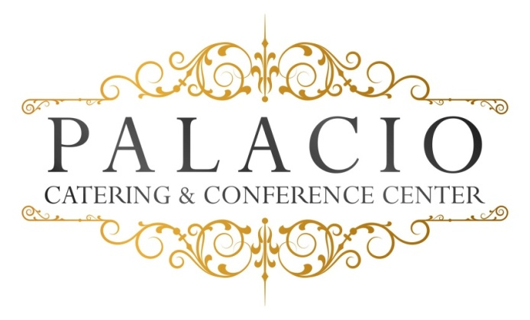

$30.00++ Buffet Saturdays $40.00++
2016 cost per person

Choice of chicken
Marsala- Francaise- Piccatta
Choice of Fish
Grilled Salmon or Stuffed sole
Choice of pasta
- Pesto- ala vodka- Alfredo
Chef’s choice starch and vegetable
Rolls and butter
House salad
Chef’s choice dessert
Iced tea- lemonade
Coffee- tea – Decaf

