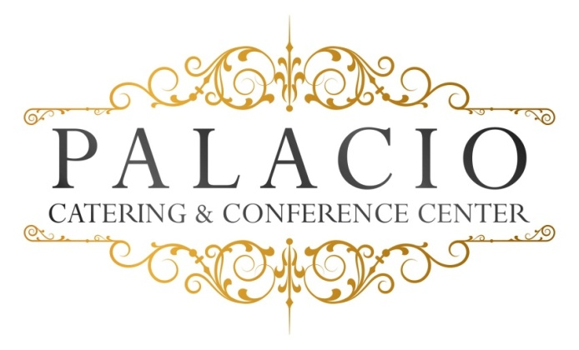

2016 cost per person

$40.00++ Buffet, Saturdays $50.00++
Choice of Fish
Grilled Salmon or Stuffed sole
Choice of Chicken
Marsala- Francaise- Piccatta
Choice of pasta
Bolgnese- Pesto- ala vodka- Alfredo
Choice of Beef
Roast sirloin- sliced roast beef
Chef’s choice Starch and Vegetable
Rolls and Butter
House salad
Desserts Chef’s choice
Iced tea- lemonade- soda and or Coffee- tea -decaf

