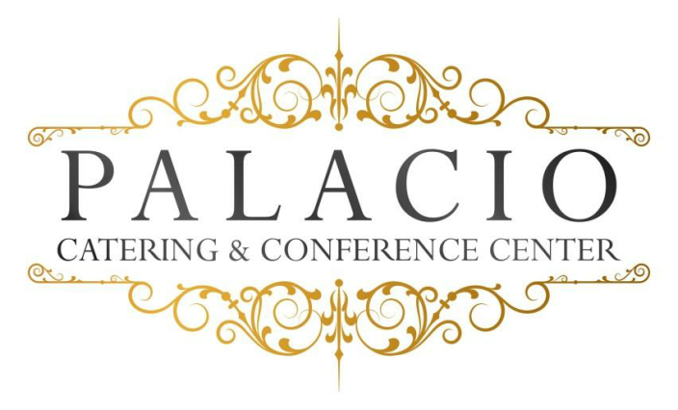
2016 cost per person

Bar/Bat Mitzvah
$52.00++ per person $58.00++ on Saturdays
Minimum of 75 People Buffet style
Tax & Service Charge not included

Hors d’ oeuvres: (choose six)
. Domestic meat & cheese . Jalapeño Poppers . Pork pot Stickers . Stuffed Mushrooms . Mini spring rolls . Pigs in a blanket . Mini pizza bites
. Fried calamari . Fried ravioli . Beef satay . Buffalo wings
Salads: (choose one)
. Tossed garden . Caesar
Main Course: (choose four)
Choice of chicken
Marsala- francaise- piccatta – Chicken Fingers with Fries
Choice of pasta
Bolognese- pesto- ala vodka- Mac & Cheese
Choice of seafood
Spinach stuffed sole- salmon
Choice of beef
Roast sirloin- sliced roast beef

Chef’s choice starch and vegetable
Rolls and butter
Chef’s choice dessert
Beverage
. Iced tea . Lemonade or Soda
Shirley Temples add $2.00 per person
Frozen Mock tails $5.00 per person (one Flavor)
Package Upgrades Available
Chocolate Fountain add $5.00 per person
Sundae Bar Add $4.00 per person

Audio Visual Screens $200.00

Cash or Run Tab subject to $75.00 Bartender fee

February 2018

