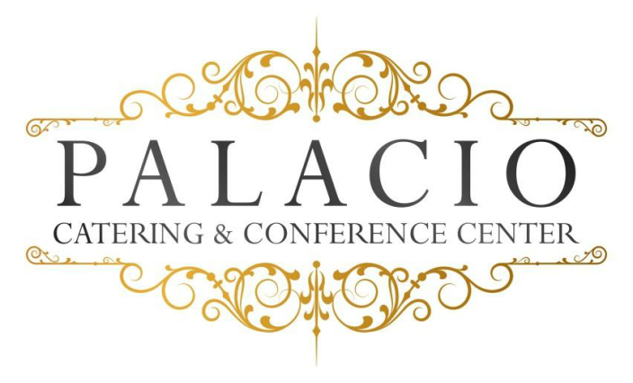
2016 cost per person

Bar Mitzvah
$50.00++ per person $60.00++ on Saturdays
Minimum of 75 People Buffet style

Hors d’ oeuvres: (choose six)
. Vegetable Crudités . Jalapeño Poppers . Pork pot Stickers . Stuffed Mushrooms . Mini spring rolls . Pigs in puffed pastry . Mini pizza bagels
. Fried calamari . Fried ravioli . Beef satay . Buffalo wings
Salads: (choose one)
. Tossed garden . Caesar . Potato
Main Course: (choose four)
Choice of chicken
Marsala- francaise- piccatta – Chicken Fingers with Fries
Choice of pasta
Bolognese- pesto- ala vodka- Mac & Cheese
Choice of seafood
Spinach stuffed sole- salmon
Choice of beef
Roast sirloin- sliced roast beef

Chef’s choice starch and vegetable
Rolls and butter
Chef’s choice dessert
Custom cake (additional charge)
Beverage
. Iced tea
. Lemonade

Shirley Temples add $2.00 per person
Frozen Mocktails add $350.00

January 2015

