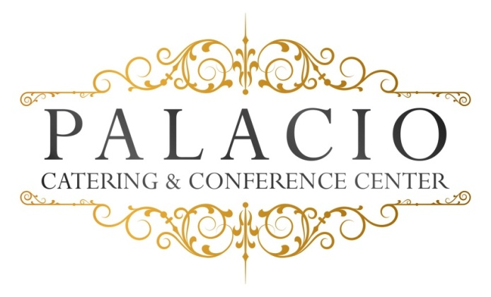

Buffet I
Monday – Thursday ONLY
$35.00 Plus NYS Tax & 20% Service per person
Domestic meat & cheese Platter
(Choose One of each)
Choice of chicken
Marsala- Francaise- Piccatta
Choice of Fish
Grilled Salmon or Stuffed sole
Choice of pasta
- Pesto- ala vodka- Alfredo
Chef’s choice starch and vegetable
Rolls and butter
House salad
Chef’s choice dessert
Soda
Coffee- tea – Decaf

