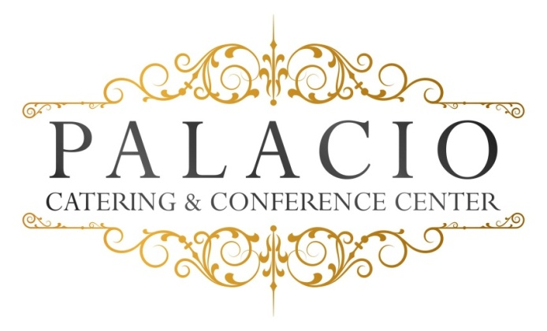

Brunch
2016 cost per person

$35.00 per person ++ 75 Guests minimum

Brunch served with orange & Cranberry juices

Fresh brewed Regular coffee, hot tea & or decaffeinated

- Assorted Breakfast Pastries to include muffins, Danish, bagels and assorted breads
- Assorted cream cheeses and jellies
- Yogurt Parfait
- Seasonal fruit platter
- Fluffy Scramble eggs
- Home Fries
- Bacon & sausage
- French Toast
- Green salad
- Chicken Francaise
- Seasonal Vegetables & Starch
- Assorted Desserts

- Carving Station: Turkey or Ham.$5.00 per person

All ingredients sourced from local Hudson Valley providers.

