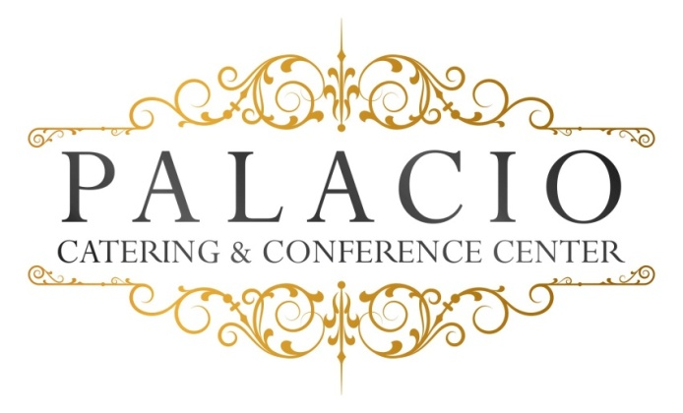

Dinner Options

Plated Dinner Options I:
Monday- Thurs $55.00, Friday & Sunday $60.00, Sat. $65.00
Plus NYS Tax & 20% Service Fee
Please call for minimum Guest count

Cocktail Hour Choice of 4 Hors D’oeuvres

Salad Course: (Choose one)

Salad:
- House Salad -- Traditional mixed greens with cherry tomatoes and balsamic vinaigrette
- Classic Caesar Salad – Fresh romaine lettuce with seasoned croutons and Parmesan cheese in our House Caesar dressing

Entrée Choice (Choose 3)

Beef:

- Grilled New York Steak – Steak grilled with fine fried onions (served medium)
- Roasted Sirloin steak – Mushroom with shallot demi glace

Pork:
- Roasted Pork loin – Stuffed with garlic, spinach, roasted peppers and fontina cheese

Chicken:
- Picatta - Breast of chicken sautéed with capers, white wine, fresh herbs and sweet cream butter.
- Francaise – Egg-battered and pan-fried breast of chicken with chopped fresh parsley, lemon, white wine, and finished with sweet cream butter.
- Parmigiana – Breaded breast of chicken with marinara sauce and mozzarella.

Fish:
- Seared Mahi- Mahi – Served with pineapple-mango salsa
- Salmon – Baked and served with a Dijon mustard sauce
- Stuffed Sole – Filet of Sole stuffed with spinach and sundried tomatoes
Vegetarian or Gluten Free (upon request)

Our chef will select an appropriate vegetable and starch to accompany your entrée selections.
All entrees served with warm rolls and butter.

Dessert
Viennese Platter for each Table

Freshly-brewed coffee, hot tea, decaf, lemonade and unsweetened iced tea.

All ingredients sourced from local Hudson Valley providers.

