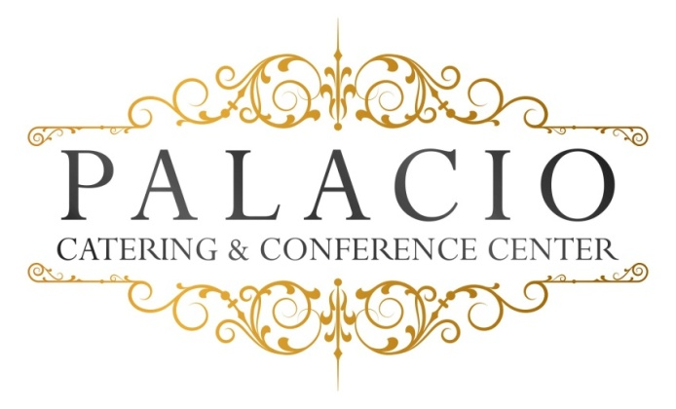

Dinner Options

Plated Dinner Option II
Monday- Thurs $60.00, Friday & Sunday $65.00, Sat. $70.00
Plus NYS Tax & 20% Service Fee
Please call for minimum Guest count
Cocktail Hour Choice of 4 hors D’ouevres

First Course (Choose One Appetizer)
Appetizer:
- Maryland Crabcakes – Jumbo lump crab cakes served with Remoulade sauce
- Penne Ala Vodka – Penne pasta served with creamy vodka sauce
Salad: (Choose one)
- House Salad – Traditional mixed greens with cherry tomatoes and balsamic vinaigrette
- Classic Caesar Salad – Fresh Romaine lettuce with seasoned croutons and Parmesan cheese in our House Caesar dressing
- Spinach Salad – Fresh spinach with mandarin oranges and red onions with a sesame vinaigrette

Main Course (Choose 3)
Beef:
- Roast Sirloin- Wild mushrooms , shallot demi glace
- Prime Rib au jus .
- Hanger Steak- Arugula pesto
Pork:
- Roast Porkloin – Mojo marinated, black bean avocado salsa
Chicken:
- Picatta - Breast of chicken sautéed with capers, white wine, fresh herbs, cream and sweet cream butter.
- Francaise – Egg- battered and pan-fried breast of chicken with chopped fresh parsley, lemon, white wine, and finished with sweet cream butter.
- Chicken Parmagiana- Breaded breast of chicken with marinara and fresh mozzarella

Fish:
- Pan seared Mahi Mahi – Served with pineapple-mango salsa
- Stuffed Filet of Sole – Stuffed with fresh spinach and sundried tomatoes in a lemon butter sauce
- Roasted Salmon – Served with fresh herbs and Dijon mustard sauce

Our chef will select an appropriate vegetable and starch to accompany your entrée selections.
All entrees served with warm rolls and butter.

Desserts (Choose one)
Chocolate Mousse
Cheesecake (seasonal fruit topping)
Viennese Plate (one per table)
Petit Fours with Ice Cream

Freshly brewed coffee, hot tea, and decaf.

All ingredients sourced from local Hudson Valley providers.

