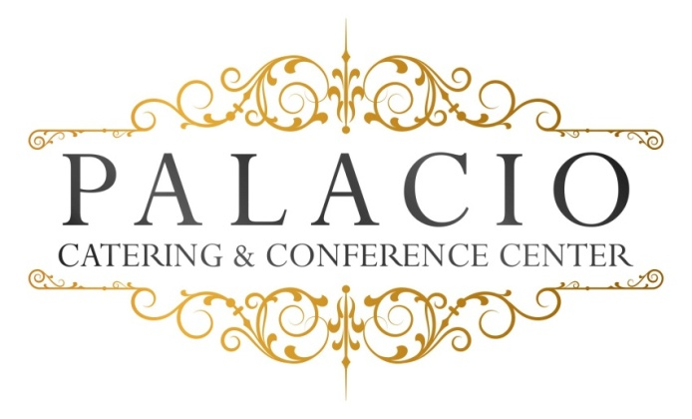

Dinner Options
2016 cost per person

Plated Dinner Option III
$65.00++ per person – Saturday $70.00++ per person

Cocktail Hour Choose 6 hors D’ouevres

First Course/Appetizer (Choose two)

- Maryland Crabcake – Jumbo lump crab cakes served with Remoulade sauce
- Shrimp Cocktail (4) Jumbo shrimp
- Eggplant Rollatini – Thinly-sliced sautéed eggplant layered with creamy Ricotta cheese, Parmesan cheese, and parsley, rolled and served in a chunky marinara sauce.
- Prosciutto Melon – Fresh cantaloupe melon, thinly sliced Prosciutto de Parma

Second Course (Choice of One)
Salad:
- House Salad – Traditional mixed greens with grated carrots, red cabbage, seasoned croutons and choice of dressing including a balsamic vinaigrette
- Classic Caesar Salad – Fresh Romaine lettuce with seasoned croutons and Parmesan cheese in our House Caesar dressing
- Spinach Salad – Fresh spinach with mandarin oranges and red onions with a sesame vinaigrette
- Hudson Valley Salad – Mixed greens, goat cheese, peas, cranberries, and pecans with a balsamic vinaigrette

Pasta Options: (Choice of One)
- Primavera – Fresh spring vegetables ,garlic and olive oil over penne.
- Tri-Color Tortellini – Tri-color cheese-filled tortellini pasta served in a roasted garlic cream sauce garnished with parsley and parmesan cheese.
- Rigatoni Bolagnese – Browned ground sirloin with red wine, fresh tomatoes and herbs over rigatoni pasta.

Entrees (Choose Three)
Beef:
- Roast sirloin- Wild mushrooms, shallot demi glace
- Grilled New York Steak – Caramelized onions
- Filet of Beef- béarnaise sauce
- Hanger Steak- arugula pesto

Pork:
- Roast Pork loin – Stuffed with spinach, roasted peppers and fontina cheese

Chicken: Choice of One
- Picatta - Breast of chicken sautéed with capers, white wine, fresh herbs, cream and sweet cream butter.
- Francaise – Egg- battered and pan-fried breast of chicken with fresh chopped parsley, lemon, white wine, and finished with sweet cream butter.
- Sorrentino – Sautéed breast of chicken with grilled eggplant, roasted peppers, prosciutto and fresh mozzarella.
- Chickem Parmigiana- Breaded chicken breast with marinara sauce and fresh mozzarella

Fish: Choice of One
- Grilled Mahi – Served with tangy pineapple-mango salsa
- Salmon Dijon – Served with Dijon mustard
- Sea Bass Fillet- Horseradish panko crust

Our chef will select an appropriate vegetable and starch
To accompany your entrée selections.
All entrees served with warm rolls and butter.

Desserts (Choose one)

Brownie sundae
Chocolate Mousse
Cheesecake (seasonal fruit topping)
Viennese Plate (one per table)
Petit Fours with Ice Cream

Freshly brewed coffee, hot tea, and decaf.

All ingredients sourced from local Hudson Valley providers.

