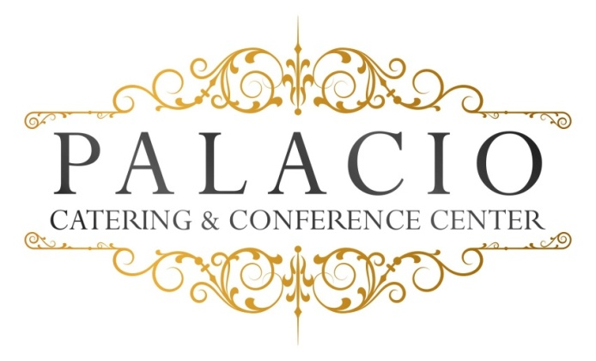

Wedding Options

Package I
Four Courses

One-hour Cocktail Reception

Five-hour Open Bar (Palacio Package)

Champagne Toast

Dinner Service

Directional Cards

Coat Check

Valet – Additional charge based on guest count

Cocktail Hour:

Hors D’oeuvres (choice of eight)

Hot – pigs in a blanket . pizza bites . mini quiche . mini spring rolls .fried ravioli . Swedish meatballs

Cold – tomato bruschetta with basil & balsamic glaze
Mozzarella & tomato skewers . smoked salmon crostini with dill cream
Prosciutto & melon . sliced cucumber with grilled vegetables & tzatziki sauce

Stationary
Domestic cold cut platter . fruit & cheese display . fried calamari . hot wings

Appetizers
Eggplant rollatini . Penne Vodka . Mozzarella Tomato Salad . Shrimp Cocktail

Salad
Mixed greens or Caesar

Entrees:
- Chicken – lemon & garlic with mushrooms . Marsala . Piccatta etc.
- Fish – Stuffed sole . Flounder . Salmon .
- Beef – Sliced steak with onions & mushrooms or Roast beef

Our chef will select an appropriate vegetable
Starch: rice, roasted potato or mashed.
All entrees served with warm rolls and butter.

Desserts
Viennese Style: cookies, brownies, petitfours

Freshly brewed coffee, hot tea, and decaf.

