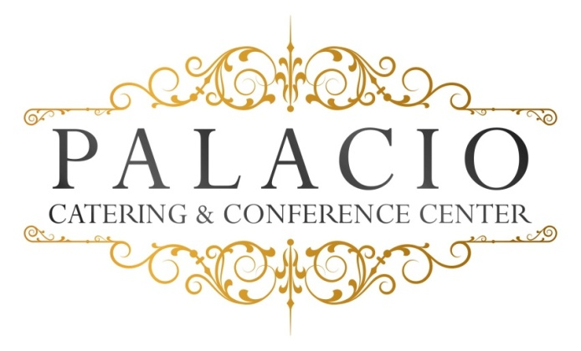

Wedding Options

Package II $125.00++ per person
Four Courses

One-hour Cocktail Reception

Five-hour Open Bar (Palacio Plus)

Champagne Toast

Dinner Service

Directional Cards

Coat Check

Valet – Additional charge based on guest count

Cocktail Hour:

Hors D’oeuvres (choice of six)

Hot – pigs in a blanket . pizza bites . mini quiche . mini spring rolls .fried ravioli . Swedish meatballs . sesame chicken . beef satay .baked clams

Cold – tomato brochette with basil & balsamic glaze
Mozzarella & tomato skewers . smoked salmon crostini with dill cream
Prosciutto & melon . sliced cucumber with grilled vegetables & tzatziki sauce . fruit kebobs . roasted beets . walnut & gorgonzola on crostini
Tuna tartare on sesame wonton craker

Stationary (choose one)
Crudités with Ranch Dip . fruit & cheese display . fried calamari . hot wings
Cold clams, oysters & shrimp tower

Appetizers
Meat balls with ricotta & tomato ragout . eggplant rollatini . Penne Vodka . Mozzarella Tomato . Shrimp Cocktail . tortellini with Italian beef sausage ragout . wild mushroom risotto . Maryland crabcake with braised artichoke, tomato, roasted pepper coulis . crab & avocado cocktail

Salad
Mix greens or Caesar

Entrees:
- Chicken – lemon & garlic with mushrooms . Marsalla . Piccatta .herb roasted ½ chicken . cordon blue . Florentine . francaise . pumante .
Or osso bucco style
- Fish – mahi mahi . Flounder . Salmon . or ahi tuna
- Beef – Roasted NY sirloin . Petite Filet mignon . herb & garlic pork loin
Or Boneless pork loin chops with brandy moshard glaze

Our chef will select an appropriate vegetable
Starch: rice, roasted potato or mashed.
All entrees served with warm rolls and butter.

Desserts
Viennese Table: cookies, brownies, petitfours . macaroon . assorted mini pastries . tartiests . mouse cups . mini canolis

Freshly brewed coffee, hot tea, and decaf.

All ingredients sourced from local Hudson Valley providers.

