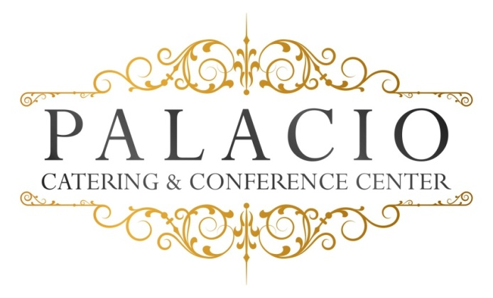

Wedding Options

Package III
Five Courses
Appetizer, Salad, Intermezzo, Entrée & Dessert.

One-hour Cocktail Reception

Five-hour Open Bar (Premium)

Champagne Toast

Intermezzo

Dinner Service

Directional Cards

Coat Check

Valet – Additional charge based on guest count

Cocktail Hour:

Hors D’oeuvres (choice of Ten)

Hot – pigs in a blanket . pizza bites . mini quiche . mini spring rolls .fried ravioli . Swedish meatballs . sesame chicken . beef satay .baked clams .coconut shrimp .mini crabcakes

Cold – tomato bruschetta with basil & balsamic glaze
Mozzarella & tomato skewers . smoked salmon crostini with dill cream
Prosciutto & melon . sliced cucumber with grilled vegetables & tzatziki sauce . fruit kebobs . roasted beets . walnut & gorgonzola on crostini
Tuna tartare on sesame wonton cracker .oysters Rockefeller .colossal shrimp cocktail

Stationary (choose two)
Cold cut meat platter .Fried calamari .hot wings
Premium seafood tower clams, oysters, shrimp & lobster
.Italian Meat &cheese display

Appetizers
Meatballs with ricotta & tomato ragout . eggplant rollatini . Penne Vodka . Mozzarella Tomato . Shrimp Cocktail . tortellini with Italian beef sausage ragout . wild mushroom risotto . Maryland crabcake with braised artichoke, tomato, roasted pepper coulis . crab & avocado cocktail .Lobster Ravioli with asparagus, cognac & tomato cream sauce . seafood risotto .King crablegs
OR
Pasta:
Penne Vodka, pesto (any pasta), tortellini with meat ragout, Fettuccini Alfredo, tomato basil & roasted garlic, Verdi (peas, onions, shallots & tomato cream, Orrechietti with sausage & broccoli rabe, Carbonara (peas, bacon, egg yolk & touch of cream.

Salad
Mixed greens, Caesar, spinach with bacon, boiled egg, tomato & feta,
Valerias (romaine, oranges, almonds, goat cheese & honey mustard dressing

Entrees:

- Poultry – Roasted ½ roasted duck, stuffed Cornish hen, lemon & garlic with mushrooms . Marsala . Piccatta .herb roasted ½ chicken . cordon bleu . Florentine . francaise . pumante . osso bucco style
- Fish – Twin Lobster tails, Chilean Seabass, red snapper, mahi mahi . Flounder . Salmon . ahi tuna
- Beef –Filet Mignon, Prime rib, roasted NY sirloin, herb & garlic sauce
- Pork loin, Boneless pork loin chops with brandy mustard glaze

Available Sauces:
Beef: Wild mushroom , port wine, Au poivre, Bernaise
Chicken: Marsala, Piccatta, Francaise, Lemon garlic, Pesto
Fish: Dijon, Horsradish cream, tomato caper & garlic

Our chef will select an appropriate vegetable

Starch: rice, roasted potato or mashed.
All entrees served with warm rolls and butter.

Desserts
Viennese Table: cookies, brownies, petitfours . macaroons
assorted mini pastries . tartlests . mousse cups . mini canolis .cake bars .cheesecake .pecan diamonds .chocolate fountain

Freshly brewed coffee, hot tea, and decaf.

All ingredients sourced from local Hudson Valley providers.

