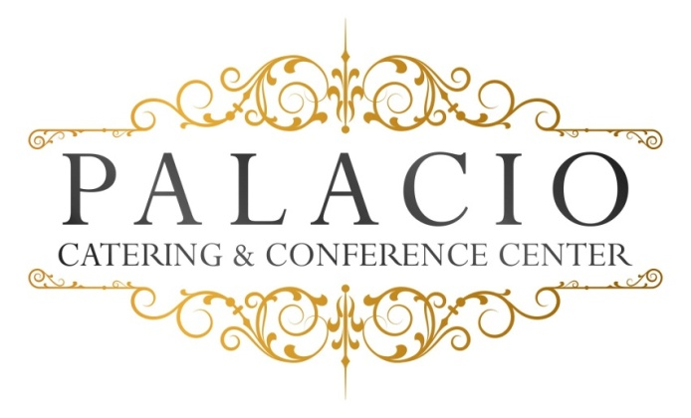

Wedding Options

Package III $150.00++ per person
Five Courses
Appetizer, Salad, Intermezzo, Entrée & Dessert.

One-hour Cocktail Reception

Five-hour Open Bar (Premium)

Champagne Toast

Intermezzo

Dinner Service

Directional Cards

Coat Check

Valet – Additional charge based on guest count

Cocktail Hour:

Hors D’oeuvres (choice of Ten)

Hot – pigs in blanket . pizza bites . mini quiche . mini spring rolls .fried ravioli . Swedish meatballs . sesame chicken . beef satay .baked clams .coconut shrimp .mini crabcakes

Cold – tomato brochette with basil & balsamic glaze
Mozzarella & tomato skewers . smoked salmon crostini with dill cream
Prosciutto & melon . sliced cucumber with grilled vegetables & tzatziki sauce . fruit kebobs . roasted beets . walnut & gorgonzola on crostini
Tuna tartare on sesame wonton craker .oysters Rockefeller .colasso shrimp cocktail

Stationary (choose two)
Crudités with Ranch Dip .Fried calamari .hot wings
Premium seafood tower clams, oysters, shrimp & lobster
.Italian Meat &cheese display

Appetizers
Meat balls with ricotta & tomato ragout . eggplant rollatini . Penne Vodka . Mozzarella Tomato . Shrimp Cocktail . tortellini with Italian beef sausage ragout . wild mushroom risotto . Maryland crabcake with braised artichoke, tomato, roasted pepper coulis . crab & avocado cocktail .Lobster Ravioli with asparagus, cognac & tomato cream sauce . seafood risotto .King crablegs
OR
Pasta:
Penne Vodka, pesto (any pasta), tortellini with meat ragout, Fettuccini Alfredo, tomato basil & roasted garlic, Verdi (peas, onions, shallots & tomato cream, Orrechietti with sausage & broccoli rabe, Carbonara (peas, bacon, egg yolk & touch of cream.

Salad
Mix greens, Caersar, spinach with bacon, boiled egg, tomato & feta,
Valerias (romaine, oranges, almonds, goat cheese & honey mustard dressing

Entrees:
- Chicken – Roasted duck, duck breast, stuffed Cornish hen, lemon & garlic with mushrooms . Marsalla . Piccatta .herb roasted ½ chicken . cordon blue . Florentine . francaise . pumante . osso bucco style
- Fish – Twin Lobster tails, Chilean Seabass, red snapper, mahi mahi . Flounder . Salmon . ahi tuna
- Beef –Fillet Mignon, Prime rib, roasted NY sirloin, herb & garlic
- pork loin, Boneless pork loin chops with brandy moshard glaze

Available Sauces:
Beef: Wild mushroom , port wine, Au poivre, Bernaise
Chicken: Marsalla, Piccatta, Francaise, Lemon garlic, Pesto
Fish: Dijon, Horse radish cream, tomato caper & garlic

Our chef will select an appropriate vegetable

Starch: rice, roasted potato or mashed.
All entrees served with warm rolls and butter.

Desserts
Viennese Table: cookies, brownies, petitfours . macaroons
assorted mini pastries . tartiests . mouse cups . mini canolis .cake bars .cheese cake .pecan diamonds .chocolate fountain

Freshly brewed coffee, hot tea, and decaf.

All ingredients sourced from local Hudson Valley providers.

