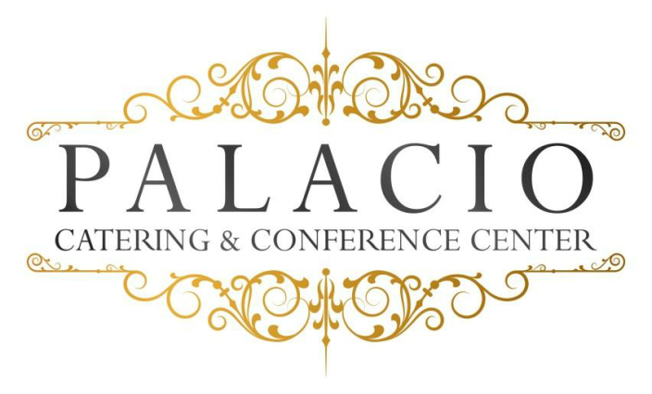
Sweet XVI / XV Añera
2018 Cost per person
$52.00++ per person Minimum of 75
$58.00++ on Saturdays Minimum of 100
Tax & Service Charge not included
This event requires security
Buffet
Hors d’ oeuvres: (choose six)
. Domestic meat & cheese . Jalapeño Poppers . Pork pot Stickers . Stuffed Mushrooms . Mini spring rolls . Pigs in blanket . Mini pizza bites
. Fried calamari . Fried ravioli . Beef satay . Buffalo wings
Salads: (choose one)
. Tossed garden . Caesar
Main Course: (choose four)
Choice of chicken
Marsala- Francaise- Piccatta – Chicken Fingers with Fries
Choice of pasta
Bolognese- Pesto- Ala vodka- Mac & Cheese
Choice of Seafood
Stuffed sole- Salmon
Choice of Beef
Roast sirloin- Sliced roast beef

Chef’s Choice Starch and Vegetable
Rolls and Butter
Chef’s choice Dessert
Beverage
. Iced tea . Lemonade or Soda
Shirley Temples add $2.00 per person
Frozen Mock tails $5.00 per person (one Flavor)
Package Upgrades Available
Chocolate Fountain add $5.00 per person
Sundae Bar Add $4.00 per person

Audio Visual Screens $200.00

Cash or Run Tab subject to $75.00 Bartender fee

February 2018

