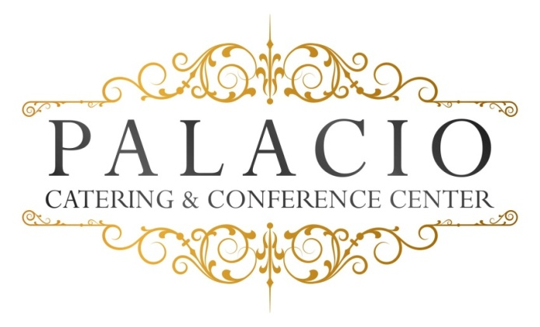

Buffet II
Week Days $45.00, Friday & Sunday $50.00 Saturday $55.00
Plus NYS Tax & 20% Service per person
Domestic meat & cheese Platter
(Choose One of each)
Choice of Fish
Grilled Salmon or Stuffed sole
Choice of Chicken
Marsala- Francaise- Piccatta
Choice of pasta
Bolgnese- Pesto- ala vodka- Alfredo
Choice of Beef
Roast sirloin- sliced roast beef
Chef’s choice: Starch and Vegetable, Rolls and Butter, House salad
Desserts Chef’s choice, Coffee- tea –decaf & soda

