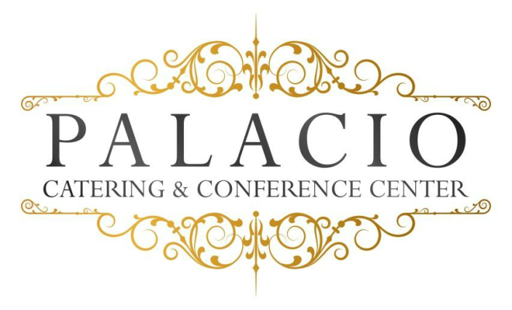
Hors plus Buffet Menu
Monday- Thurs $55.00, Friday & Sunday $60.00, Sat. $65.00
Plus NYS Tax & 20% Service Fee
Please call for minimum Guest count
Hors d’ oeuvres: (choose six)
. Domestic Meat & cheese . Jalapeño Poppers . Pork pot Stickers . Stuffed Mushrooms . Mini spring rolls . Pigs in puffed pastry . Mini pizza bagels
. Fried calamari . Fried ravioli . Beef satay . Buffalo wings
Salads: (choose one)
. Tossed garden . Caesar . Potato
Main Course: (choose one of each)
Choice of chicken
Marsala- francaise- piccatta – Chicken Fingers with Fries
Choice of pasta
Bolognese- pesto- ala vodka- Mac & Cheese
Choice of seafood
Spinach stuffed sole- salmon
Choice of beef
Roast sirloin- sliced roast beef

Chef’s choice starch and vegetable
Rolls and butter
Chef’s choice dessert
Beverage
. Iced tea
. Lemonade
. Soda

Audio Visual Screens $200.00

Cash or Run Tab subject to $75.00 Bartender fee

February 2018

