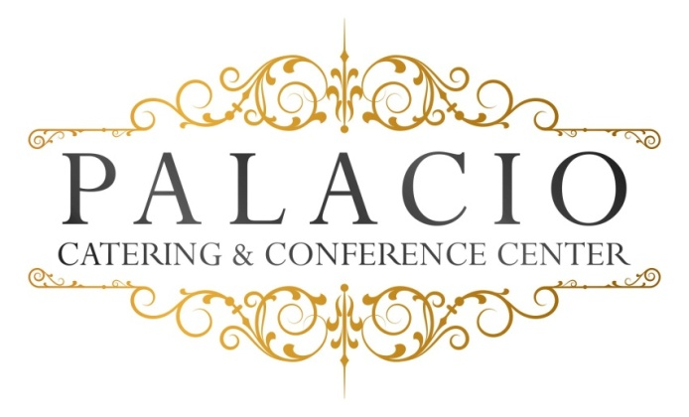

Luncheon Buffet Menu
2018cost per person

$30.00++ per person Monday - Thursday
$35.00 per person ++ Friday, Saturday or Sunday 75 Guests minimum
NYS Tax & Service Charge are not included

Salad:
. House –Mix garden salad with vinaigrette

Entrees:

Chicken:
. Picatta –Breast of chicken sautéed with capers, with wine, fresh herbs and sweet butter cream.
. Francaise –egg-buttered and pan-fried breast of chicken with parmesan reggiano, fresh parsley, lemon, wine and sweet butter.

Fish:
. Salmon Dijon –Grilled salmon with Dijon mustard and juniper berries.
. Stuffed filet of sole –stuffed with spinach in a lemon butter sauce

Pasta:
.Vodka, pesto, Alfredo or baked ziti.

Our chef will select an appropriate vegetable and starch to accompany your entrée selections.
All entrees served with warm rolls and butter.

Dessert – Chefs choice
Viennese Platter for each Table

Freshly-brewed coffee, hot tea, decaf, lemonade and unsweetened iced tea.

