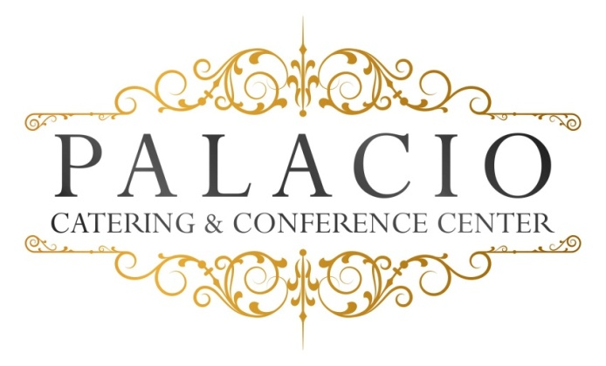

Starter Wedding Package
Please call for Cost per person

5 hour basic bar package Domestic bottled beer, wine, basic call drinks

Cocktail Hour with choice of Six
Hot – pigs in a blanket . pizza bites . mini quiche . mini spring rolls .fried ravioli . Swedish meatballs

Cold – tomato bruschetta with basil & balsamic glaze
Mozzarella & tomato skewers . smoked salmon crostini with dill cream
Prosciutto & melon . sliced cucumber with grilled vegetables & tzatziki sauce

Salad Course: (Choose one)
Salad:
- House Salad -- Traditional mixed greens with tomatoes, cucumbers with a balsamic vinaigrette
- Classic Caesar Salad – Fresh Romaine lettuce with seasoned croutons and Parmesan cheese in our House Caesar dressing
Entrée Choice
Beef:
- Roast beef – with pan Gravy
- Roasted Sliced Sirloin Steak – Wild Mushrooms with shallot demi glace
Chicken: (choose one)
- Picatta - Breast of chicken sautéed with capers, white wine, fresh parsley and sweet cream butter.
- Francaise – Egg-battered and pan-fried breast of chicken with fresh chopped parsley, lemon, white wine, and finished with sweet cream butter.

Fish: (choose one)
- Salmon – Baked and served with a Dijon mustard sauce sauce
- Stuffed Sole – Filet of Sole stuffed spinach and sundried tomatoes
Vegetarian – Gluten Free Options Available
Our chef will select an appropriate vegetable and starch to accompany your entrée selections.
All entrees served with warm rolls and butter.

Dessert
Viennese Platter for each Table (consisting of Brownies, cookies, petit fours)

Coffee and Tea included
Soda, Iced Tea, Lemonade Included

All ingredients sourced from local Hudson Valley providers.

